There are 2 tasks each worth 50%

1. Turn to page 49 and complete question 16

Print screen your results below here

Print screen your code below here

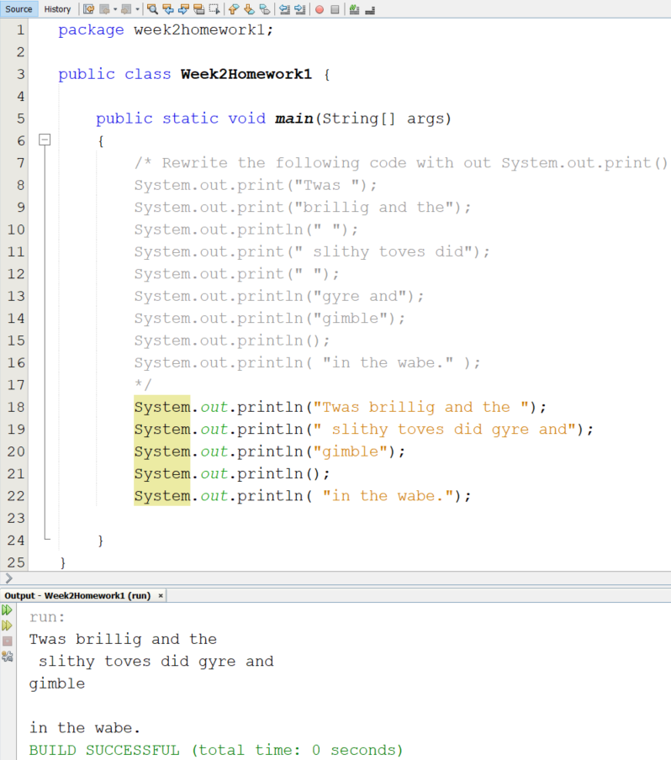

1. Complete the following below

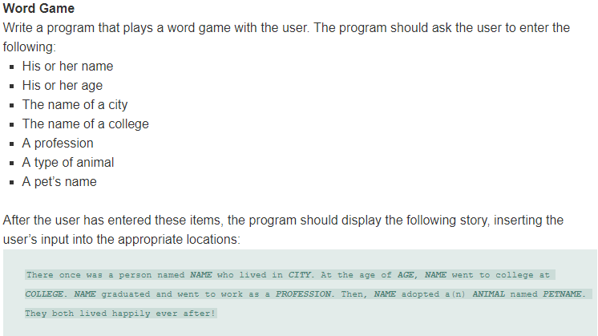 Print screen your results below here

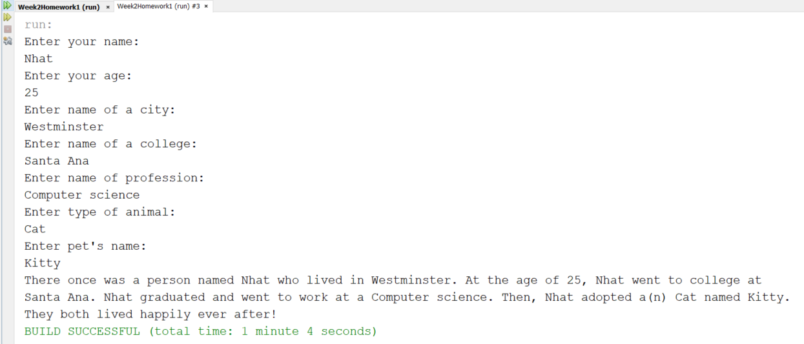

Print screen your code below here

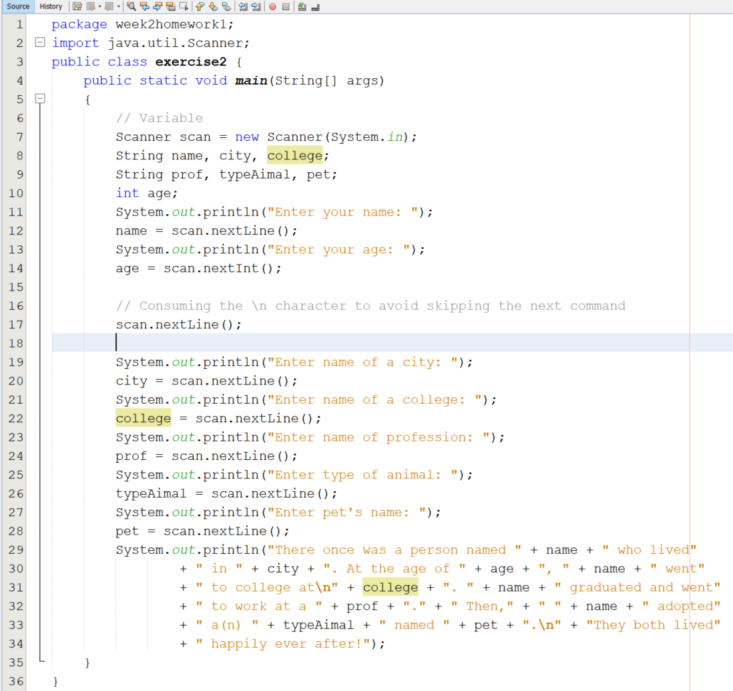

Upload this document to Week 2 Homework for Canvas